**Course: Advance Bio Informatics**

**Module Title: Lead Identification**

**Module No: 133**

**Lead Identification**

Compound for biological activity on target.

Potency threshold

Libraries of molecules

**Lead Identification Technologies**

Protein structure, docking Chemical similarity search. Knowledge of compounds against receptor, receptor structure & receptor ligand interactions

**Lead Identification**

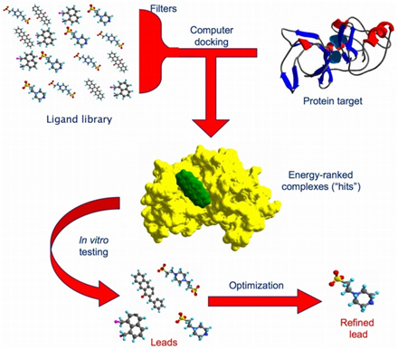

**Visual Screening**

**MLCC:** Multilevel chemical Compatibility scoring

* Top selling drugs
* Compounds under biological scrutiny
* Anticancer drugs
* Compounds with poor drug like characters

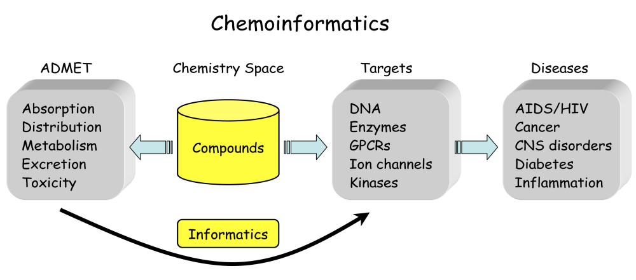

**Pharmacophore Mapping**

Identify lead compounds against a desired target

**Definition:** 3-D arrange…

**Usage:** interaction of receptor & legend

DB concept

**QSAR** Quantitative structure activity relationship

**SAR:** synthesizing & testing a series of structurally related compounds

Least squares & KNNs

**High Throughput Docking**

Ligand & protein

Docking algorithms

Force fields, knowledge based & empirical

**NMR based screening**

Nuclear Magnetic Resonance

3-D potential DC & tertiary structure of Proteins

Need of prior information

SHAPES

WaterLogsy

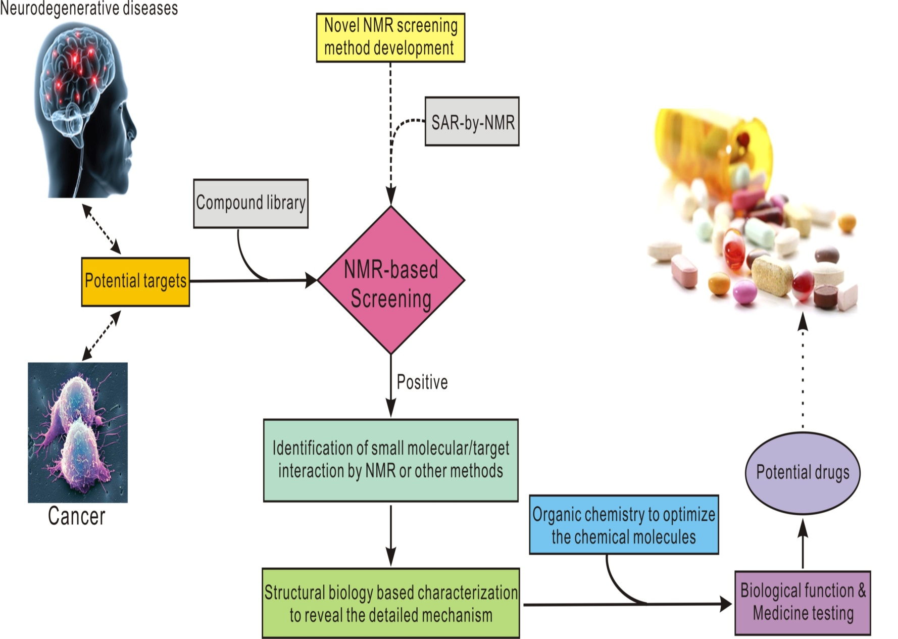

**Chemical Genetics**

Gene-product function in cellular or organismal context using exogenous ligands

Knockouts

Cell cycle - arresting agents